Q1). Return all actors whose last names are ALLEN from the actor table.

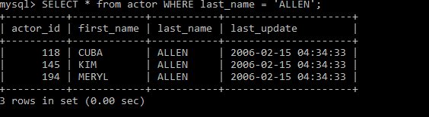

2. Return all the actors who’s last_name column has a value DAVIS, and the row’s first_name has a value SUSAN.

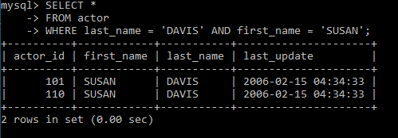

3. Return all actors where last_name column has a value ALLEN or DAVIS.

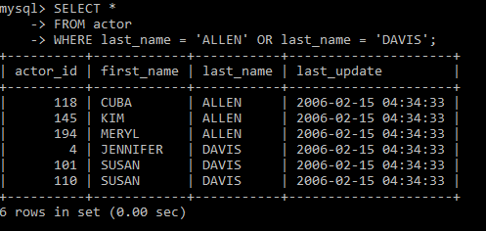

4. Return the number of categories which have a name that does not start with the letter A.

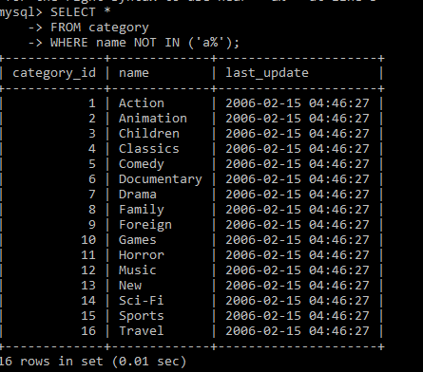

5. Return all actor names and the name of each film title they were in.

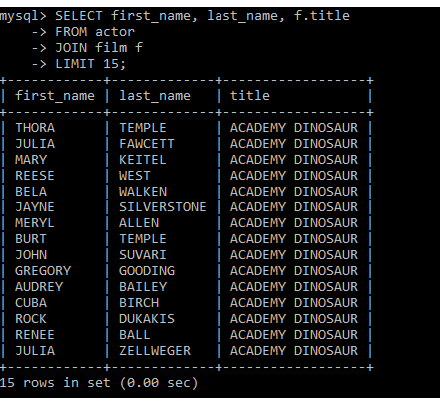

6. Return the title, release year, and category of all movies.

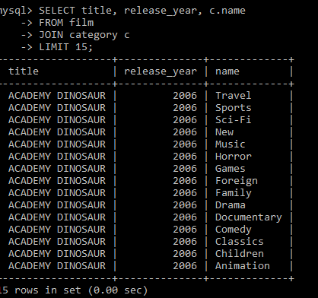

7. Return how much JOHNNY TURPIN has spent on movie rentals.